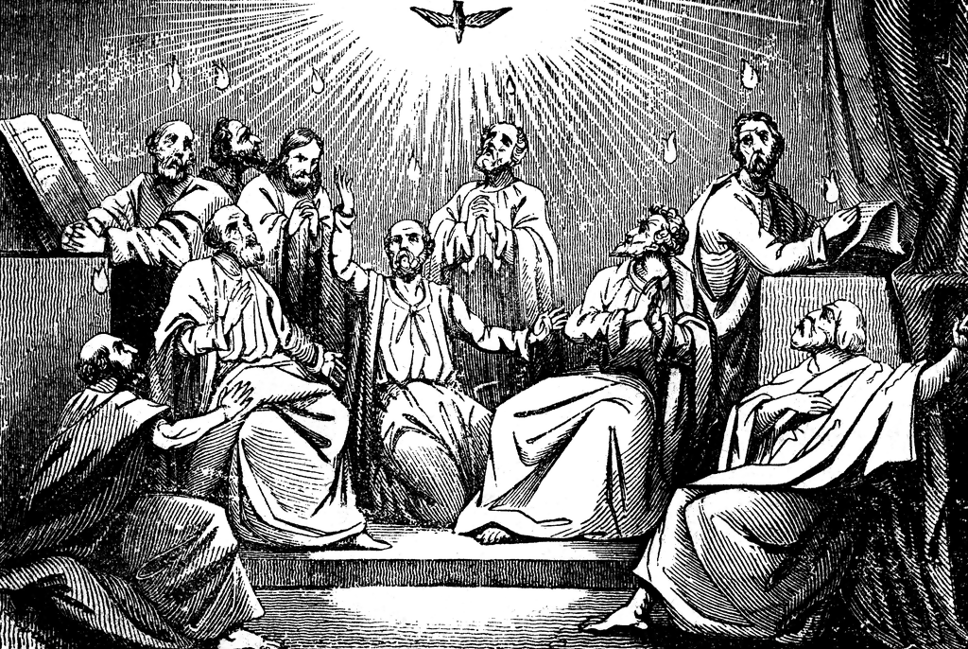

By this he meant the Spirit, whom those who believed in him were later to receive.
John 7:39a

The Coming of the Holy Spirit—The Day of Pentecost
May 28, 2023

Welcome! We are glad you are here! In worship, we gather before the almighty God to offer him the praise that is due his name and to be fed by his life-giving Word. This service folder will guide you through our path of worship. If you have any questions, please don’t hesitate to ask an usher or the person sitting next to you. God bless your time in this house of God.

Bathrooms are located in the fellowship hall. A changing table is located in the women’s bathroom.

A worship monitor is to the right as you exit. We encourage children of all ages to participate in our worship. Please bring them into the service. We have a nursery room with toys, books, and other items that you can use with your child.
Before you leave, please sign our guest register. Located on the lectern in the entryway.

OPENING HYMN Father, We Praise You CW 581

M: In the name of the Father and of the Son and of the Holy Spirit.
C: Amen.
Confession and Absolution
M: God so loved the world that while we were yet sinners, Jesus Christ was given to die for us. Through the power of the Holy Spirit, God promises to heal us and forgive us. Let us confess our sins in the presence of God and one another.
(Silence for personal reflection)
M: Jesus invites you: “Come to me, all you who are weary and burdened, and I will give you rest.” (Matthew 11:28)

C: We have come to the Lord’s house wearied by our work and burdened by our problems.

M: Isaiah said of the Savior: “A bruised reed he will not break,” (Isaiah 42:3) and again: “He was bruised for our iniquities … by his wounds we are healed.” (Isaiah 53:5)
C: We have come bruised by the actions and bruised by our repeated falls into sin.

M: Isaiah says that God the Father sent Jesus “to bind up the brokenhearted, to proclaim freedom for the captives…to comfort all who mourn.” (Isaiah 61:1-2)
C: We come broken in spirt because we cannot pay for our wrongs, broken in heart because we long for the peace of forgiveness.

M: God, our heavenly Father, has been merciful to us and has given his only Son to be the atoning sacrifice for our sins. Therefore, as a called servant of Christ and by his authority, I forgive you all your sins, in the name of the Father, and of the Son and of the Holy Spirit.
C: Amen.

Prayer and Praise
M: In the peace of forgiveness, let us praise the Lord:
C: I lay my sins on Jesus, The spotless Lamb of God
He bears them all and frees us From the accursed load.
I bring my guilt to Jesus To wash my crimson stains
White in his blood most precious Till not a spot remains.

PRAYER OF THE DAY
M: Holy Spirit, God and Lord, come to us this joyful day with your sevenfold gift of grace. Rekindle in our hearts the holy fire of your love that in a true and living faith we may tell abroad the glory of our Savior, Jesus Christ, who lives and reigns with you and the Father, one God, now and forever.
C: Amen.

The Word

FIRST LESSON Acts 2:1-21

PSALM OF THE DAY Psalm 51b (CW pg. 87)
SECOND LESSON 1Corinthians 12:3-11

GOSPEL ACCLAMATION
M: Alleluia. Come, Holy Spirit, fill the hearts of your faithful people, and kindle in them the fire of your love. Alleluia.

SEASONAL RESPONSE

C: ♫ I long to be like Jesus: Meek, loving, lowly, mild;
I long to be like Jesus, The Father’s holy child.
I long to be with Jesus Amid the heav’nly throng
To sing with saints his praises, To learn the angels’ song.

GOSPEL John 7:37-39

M: This is the gospel of the Lord.
C: Praise be to you, O Christ!

HYMN OF THE DAY Come, Holy Ghost, God and Lord CW 176

SERMON

APOSTLES CREED

M: In a world that has difficulty believing in the one true God, but
is so ready to believe that our universe happened by some unknown accident, what do you believe?
C: I believe in God, the Father almighty, maker of heaven and earth.

M: In a society that so quickly rejects what God did through His Son, what do you believe?
C: I believe in Jesus Christ, His only Son, our Lord, who was conceived by the Holy Spirit, born of the virgin Mary, suffered under Pontius Pilate, was crucified, died, and was buried.
M: While many put their trust in things or people that they make into their gods, what do you believe that Jesus did that proves He has conquered death and is true God just as He said?
C: He descended into hell. The third day he rose again from the dead. He ascended into heaven and is seated at the right hand of God the Father almighty. From there He will come to judge the living and the dead.
M: Those who refuse to trust the Lord are without hope. What do you believe that gives you hope?
C: I believe in the Holy Spirit, the holy Christian Church, the communion of saints, the forgiveness of sins, the resurrection of the body, and the life everlasting. Amen.
OFFERING
We joyfully respond to our Shepherd’s loving care by praising him with all we are and all we have. Bringing an offering is an act of trust in God’s promises to provide and an acknowledgement that “my cup overflows.” A joyful and generous offering is always a wonderful way to show Jesus that he is our greatest treasure and worthy of our praise. May God be praised through our offerings!

PRAYER OF THE CHURCH
M: Spirit of love, teach us to do your will. Preserve our lives. Bring us through all trouble. Lead us on level ground.
Come, Holy Spirit, fill the hearts of your people.
C: Kindle in us the fire of your love.

M: Spirit of grace, enlighten us with your gifts. Put your Word before us, in our eyes, ears and hearts, that we may be full of wisdom, knowledge, faith and all your gifts.
Come, Holy Spirit, fill the hearts of your people.
C: Kindle in us the fire of your love.
M: Spirit of mercy, call people everywhere to faith by your gospel. Bring them from the darkness of sin to your wonderful light. Open our lips to declare your praise, and lead many more to call on the name of the Lord and be saved.
Come, Holy Spirit, fill the hearts of your people.
C: Kindle in us the fire of your love.
M: Spirit of peace, like a holy wind, blow across the whole world. Govern and guide the leaders of all nations, so that your Word may have free course, and that we may live in peace.
Come, Holy Spirit, fill the hearts of your people.
C: Kindle in us the fire of your love.
M: Spirit of power, strengthen us to do your work for the common good. Give your various gifts to each one of us to meet the needs of your church, that God’s kingdom may come and that your glory may be shown.
Come, Holy Spirit, fill the hearts of your people.
C: Kindle in us the fire of your love.
M: Spirit of compassion, give your gift of healing to those who suffer illness, pain or discomfort of mind or body, [especially…]. With the power of your Word, turn all hardships into blessings, and give your people patience, character and hope.
Come, Holy Spirit, fill the hearts of your people.
C: Kindle in us the fire of your love.
Special prayers and intercessions may follow.
M: Listen, Lord, to the thoughts and cares of our hearts.
Silent prayer

M: Holy Spirit, dwell in our hearts. Rule and direct us according to your will, comfort us in all temptations and afflictions, defend us from all error, lead us into all truth, keep us steadfast in the true faith, and help us increase in love and in all good works, that in the end we obtain eternal life; through Jesus Christ our Lord, who lives and reigns with you and the Father, one God, now and forever.
C: Amen.
LORD’S PRAYER
C: Our Father, who art in heaven, hallowed be thy name, thy kingdom come, thy will be done on earth as it is in heaven. Give us this day our daily bread; and forgive us our trespasses, as we forgive those who trespass against us; and lead us not into temptation, but deliver us from evil. For thine is the kingdom and the power and the glory forever and ever. Amen

HYMN God Has Spoken by His Prophets CW 281

M: Blessed Lord, you have given us your Holy Scriptures for our learning. May we so hear them, read, learn, and take them to heart, that being strengthened and comforted by your holy Word, we may cling to the blessed hope of everlasting life, through Jesus Christ, our Lord, who lives and reigns with you and the Holy Spirit, one God, now and forever.
C: Amen.

BLESSING

M: Brothers and sisters, go in peace. Live in harmony with one another. Serve the Lord with gladness.
The Lord bless you and keep you.
The Lord make his face shine on you and be gracious to you.
The Lord look upon you with favor and give you peace.
C: Amen. Amen. Amen.

CLOSING HYMN There Is a Balm in Gilead CW564

Come worship with us again!
A Special Service
Next Sunday, June 4^{H} - 4:00 pm
Installation of Pastor Tim Leistekow

VACANCY PASTOR

Christopher Hoppe, Pastor stjohnluthvaca@outlook.com
(920) 652-4003 www.stjohnvacaville.org
christopherhpp@gmail.com

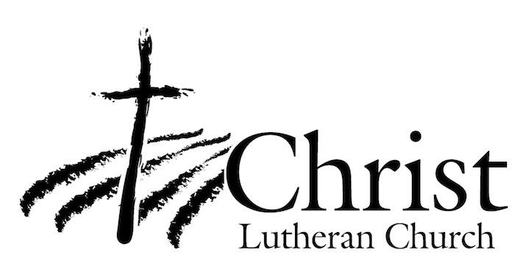
13009 N. Elderberry Ct.
Lodi, CA 95242
www.christlodi.org
209-368-6250
WELCOME TO CHRIST EV. LUTHERAN CHURCH!
We preach a message of forgiveness, hope and peace
through the death and resurrection of Jesus Christ.
Families and individuals of all ages will find opportunities
both to grow and to serve.

Our mission statement:
Look what Christ is doing!
He binds us together in fellowship
He gathers us in for worship
He builds us up for service
He sends us out with the gospel

“Now you are the body of Christ,
and each one of you is a part of it.”
(1 Corinthians 12:27)

